Your Museum

SRS

Introduced By Your museum Co.

|  |  |  |  |  |
| --- | --- | --- | --- | --- |
| Version | Written By | Reviewed By | Approved By | Date |
| 0.X |  |  |  |  |
| 1.X |  |  |  |  |

Contents

1 Introduction 4

1.1 Executive Summary 4

1.2 Document Overview 4

1.3 Abbreviations and Terminologies 4

1.4 References 4

2 System Description 4

2.1 Introduction 4

2.2 Users 4

2.2.1 Regular users 4

2.2.2 professional individual artists 4

2.2.3 Museum representative 4

2.2.4 Site administrator/content manager 4

2.3 Modules 5

2.3.1 Museum module 5

2.3.2 auction module 5

2.3.3 Exhibition module 5

2.3.4 Community module 5

3 System Users 6

3.1 Museum representative 6

3.2 Regular user 6

3.3 Professional artist 6

3.4 Rare art owners 6

3.5 Site administrator/content manager 6

4 System Modules 7

4.1 Exhibition Module 7

1.2 Search & View account 7

Sell arts 7

1.1 Exhibition Module 7

search 7

1.4 Buy arts 7

upgrade account 7

4.2 Community Module 8

search 8

1.3 Community Module 8

8

4.3 Auction Module 8

4.4 Museum Module 8

5 System Functions 8

5.1 Exhibition Module Functions 8

5.1.1 upgrade account 8

5.1.2 add art work 8

5.1.3 sell art work 9

5.1.4 buy art work 9

5.2 Community Module Functions 9

5.2.1 add art work 9

5.2.2 like and rate art work 9

5.2.3 comment on art work 9

5.3 Museum Module Functions 9

5.3.1 add artwork 9

5.3.2 add replicas and gifts 9

5.3.3 buying gifts 10

5.3.4 searching 10

5.3.5 commenting on artworks 10

5.3.6 liking artworks 10

5.4 Auction Module Functions 10

5.4.1 add arts 10

5.4.2 buying arts 10

6 System Models 11

11

6.1 Use Case Diagrams 12

6.1.1 exhibition module user case diagram 12

6.1.2 community module user case diagram 13

6.1.3 Museum module user case 14

6.1.4 Auction module User Case 14

6.2 Sequence Diagrams 15

6.2.1 Sequence Diagram 15

6.2.2 Sequence Diagram 15

7 Non-Functional Requirements 15

7.1 Security Requirements 15

7.1.1 password 15

7.2 Usability Requirements 15

7.2.1 Usability Requirement 15

7.3 Performance Requirements 15

7.3.1 Response time 15

7.4 Art Domain Requirements 15

7.4.1 Literary and artistic property law 15

7.5 Auction Domain Requirements 15

7.5.1 Auction laws and conditions 15

8 Prototype 16

8.1 User Interfaces 16

8.1.1 Sign up interface 16

8.1.2 Sign in interface 16

8.1.3 All Museums interface 17

8.1.4 Certain Museum interface 17

8.1.5 Art exhibit interface 18

8.1.6 Auction interface 18

8.1.7 Community section interface 19

8.2 Hardware Interface 19

# Introduction

## Executive Summary

Overview of product.

## Document Overview

Overview of the document.

## Abbreviations and Terminologies

Table of abbreviations and terminologies.

## References

[1]

[2] http://en.cabinetbouchara.com/droit-propriete-litteraire-artistique.html

# System Description

## Introduction

Online museum is a web site that help people who can’t afford to visit real museums to see ,appreciate ,and learn from different kind of arts from around the world, and the site also provide an online opportunity for museums ,amateur artists , professional artist to display their art work and monuments , and the site also provide a service where users can buy and sell their art work .

## Users

### Regular users

Regular people who are interested and want to experience art and monuments. and amateur artists who want to display their art and take feed back from people have the choice to do so as a regular user.

### professional individual artists

professional artists who already have been known for their art also can use the website to display and sell their new work.

### Museum representative

museums can display monuments and art they have and let people rate it and it serve as a way of advertisement and sharing the knowledge.

### Site administrator/content manager

## Modules

### Museum module

This module is where different museums can have an account and display some of their monuments, and as a sub module every museum can have a gift shop where users “viewers” can buy souvenirs, and users with accounts can see pictures of different kind of monuments and art, with a brief history or a description.

### auction module

This module is where owners of rare arts got to sell their piece and to decide the starting price of the piece, period of the auction. then it allows other users to participate in the auction and then eventually buy the piece. the site will charge for this service.

### Exhibition module

In this module professional artists can display their work and decide a price for their work, sell their work, and for regular people to buy some professional art online. the site will charge for this service.

### Community module

Open to users with regular subscription, here amateur artists can share any kind of art and let other people rate it and comment on it, and for viewers to see, comment, and rate.

# System Users

## Museum representative

Every museum with an account must have a representative who is responsible of adding picture, and adding items to the gift shop, and they also can participate in the auction module.

## Regular user

Regular users can be just viewers who visit the site just to see some art either in the museum module, or in the community module and they can rate and comment on items, or they can contribute in the community module by adding amateur arts, and they also can participate in the auction module.

## Professional artist

Professional artist who is popular, can have a page in the exhibition module where he can sell his work, and they also can participate in the auction module.

## Rare art owners

People who have rare pieces of art can use the auction page to sell their rare arts, they decide the price, and the duration of the auction.

## Site administrator/content manager

# System Modules

## Exhibition Module

This module is where professional artists can have their own page where they can display and sell their work, they can use this module by paying a fee to the site.

## Search & View account

## Sell arts

## Exhibition Module

## search

## Buy arts

## upgrade account

Viewer

Yes: buyer

No: artist

Search view and sort

Upload work

Sell work

Buy work

Upgraded account

Upgrade

Yes

No

## Community Module

This module allows amateur artists to show their work and allow other users to rate it and comment on it.

## search

Search and sort

## Community Module

Rate and comment

## 

Add art

## Auction Module

In this mode professional artists can their put their -best- works for auction with start price and raise amount by paying auction fees to the site.

Admins manage the auction mode by organizing the schedule and put art pieces in free times.

## Museum Module

* In this mode there is list of the museums that registered to the website and search area for arts -uploaded by the museums- using kinds of sorts like eras, locations and museums.
* Each museum page has the museum content and gift shop sub module.
* Gift shop page contains the museum products with prices and data.

# System Functions

## Exhibition Module Functions

### upgrade account

**Description**​: the regular account can be upgraded where the user can sell via the account.

**Inputs**​: user name, password, and credit card information.

**Outputs**​: upgraded account.

**Pre-conditions**​: regular account.

**Post-conditions**​: users can sell their art work.

### add art work

**Description**​: users can upload pictures of their work and put a price on it then sell it.

**Inputs**​: good pictures of the art work.

**Outputs**​: uploaded pictures on artist page.

**Pre-conditions**​: upgraded account.

### sell art work

**Description**​: users can sell uploaded art work.

**Inputs**​: art work and prices.

**Outputs**​: selling art work.

**Pre-conditions**​: upgraded account.

### buy art work

**Description**​: users can buy uploaded art work.

**Inputs**​: choosing pieces.

**Outputs**​: buying art work.

**Pre-conditions**​: regular account.

## Community Module Functions

### add art work

**Description**​: users can upload pictures of their work and put a price on it then sell it.

**Inputs**​: good pictures of the art work.

**Outputs**​: uploaded pictures on artist page.

**Pre-conditions**​: regular account.

### like and rate art work

**Description**​: users can like other users work and rate it.

**Inputs**​: users vote.

**Outputs**​: accumulation of likes.

**Pre-conditions**​: regular account subscription.

### comment on art work

**Description**​: users can like other users work and rate it.

**Inputs**​: users’ comments.

**Outputs**​: accumulation of comments.

**Pre-conditions**​: regular account subscription.

## Museum Module Functions

### add artwork

**Description**​: Museum representative upload pictures and data of their artworks.

**Inputs**​: Good pictures of the artworks.

**Outputs**​: Uploaded pictures on museum page.

**Pre-conditions**​: Museum account.

### add replicas and gifts

**Description**​: Museum representative upload pictures, prices and data of their products.

**Inputs**​: Good pictures, data and prices of the products.

**Outputs**​: Uploaded products are ready to be sold on museums’ gift shop page.

**Pre-conditions**​: Museum account.

### buying gifts

**Description**​: Regular user can buy products from museums’ gift shop.

**Inputs**​: User information like phone number, e-mail, address and payment method.

**Outputs**​: User information is sent to the museum to send the products to the user.

**Pre-conditions**​: User account with complete data.

### searching

**Description**​: Users can search for the art works with many kinds of sorts.

**Inputs**​: Searching information.

**Outputs**​: Desired artwork.

**Pre-conditions**​: Provide function required conditions to work.

### commenting on artworks

**Description**​: Users can comment on museum content.

**Inputs**​: Users’ comments.

**Outputs**​: Accumulation of comments.

**Pre-conditions**​: Regular account subscription.

### liking artworks

**Description**​: Users can like museum content.

**Inputs**​: Users vote.

**Outputs**​: Accumulation of likes.

**Pre-conditions**​: Regular account subscription.

## Auction Module Functions

### add arts

**Description**​: Professional artist upload pictures and data of their artworks which they want it to be in auction and website admins organize the auction.

**Inputs**​: Pictures of the artwork, data, start price and bid amount.

**Outputs**​: Artwork scheduled for the auction.

**Pre-conditions**​: Professional account has paid the fees of the auction.

### buying arts

**Description**​: Regular user can buy arts int the auction by bidding the highest amount of money to get the art.

**Inputs**​: Your paying for the artwork.

**Outputs**​: waiting for the end of the auction -winning or losing the artwork-.

**Pre-conditions**​: Regular user account with complete data and paying method.

# System Models

## 

Viewer

Yes: buyer

No: artist

Search view and sort

Upload work

Sell work

Buy work

Upgraded account

Upgrade

## Use Case Diagrams

### exhibition module user case diagram

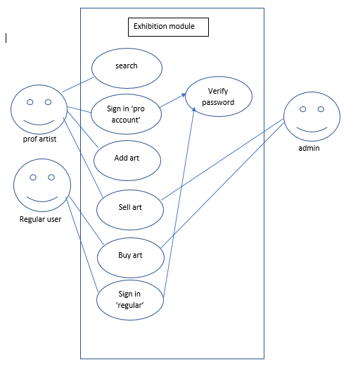

In this diagram regular users can interact with the buy function and the admin as will to manage the transaction between the artist and regular user and the prof artist can involve in the rest of the functions.

### community module user case diagram

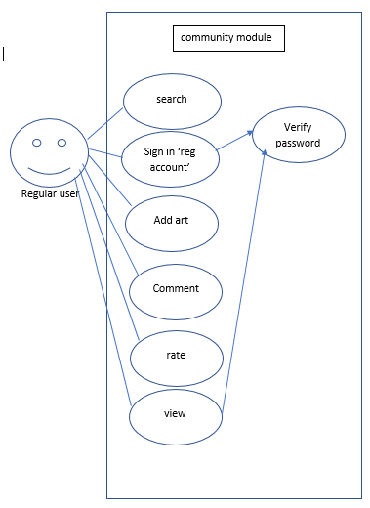

Here regular user can either add arts or just view arts

### Museum module user case

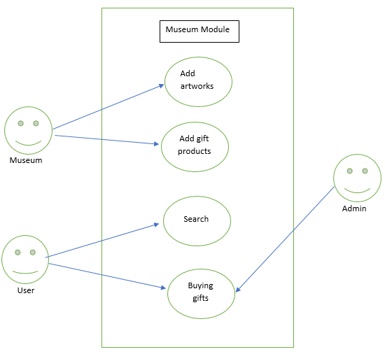

### Auction module User Case

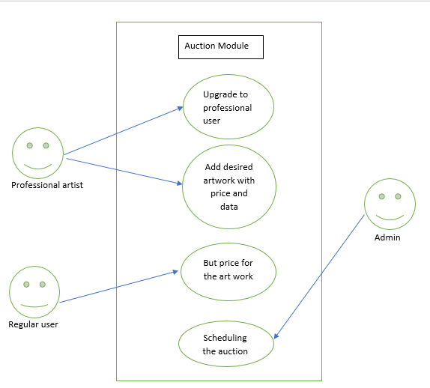

## Sequence Diagrams

### Sequence Diagram

Show sequence diagram.

Provide brief explanation of the diagram.

### Sequence Diagram

Show sequence diagram.

Provide brief explanation of the diagram.

# Non-Functional Requirements

## Security Requirements

### password

Using password for both accounts pro and regular security is very important to secure credit card info and money transaction.

## Usability Requirements

### Usability Requirement

It is important that the site is easy to use that anybody can use it.

## Performance Requirements

### Response time

It is important for response time to be minimal as much as possible especially for the auction and search function.

## Art Domain Requirements

### Literary and artistic property law

Admin must be aware of laws in case of any kind of fraud.

## Auction Domain Requirements

### **Auction laws and conditions**

Admin must be alert in auctions for any kind of manipulation.

# Prototype

## User Interfaces

### Sign up interface

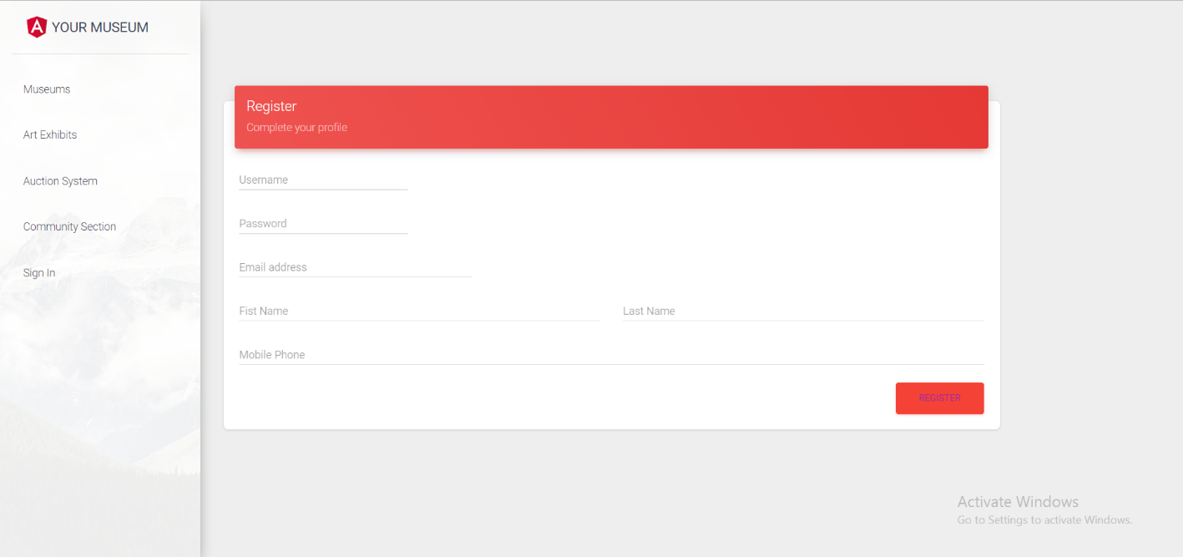

### Sign in interface

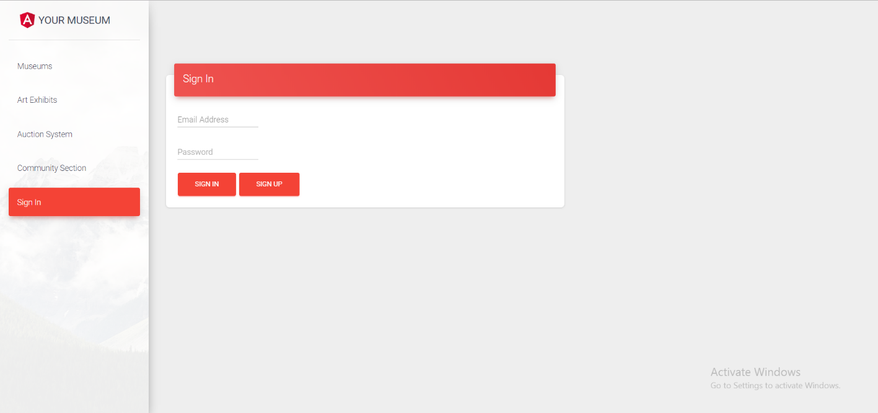

### All Museums interface

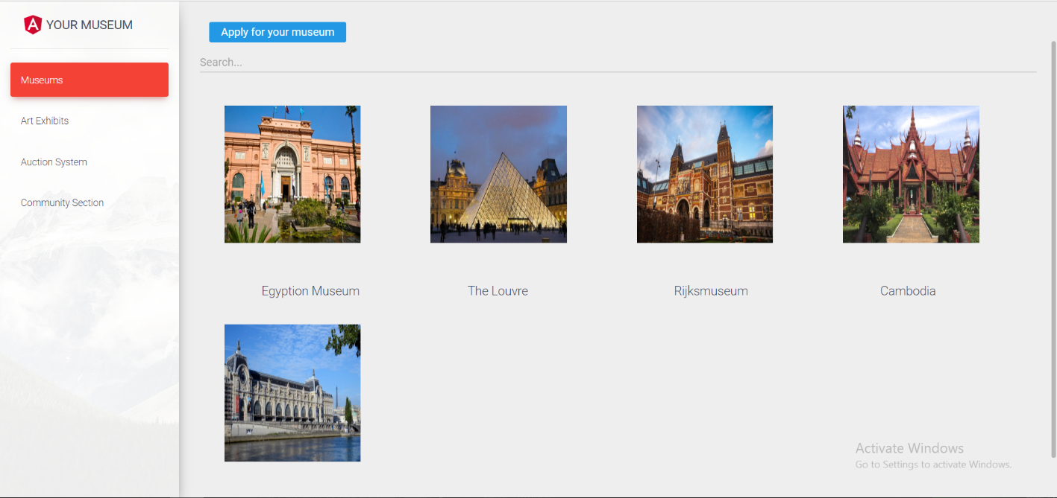

### Certain Museum interface

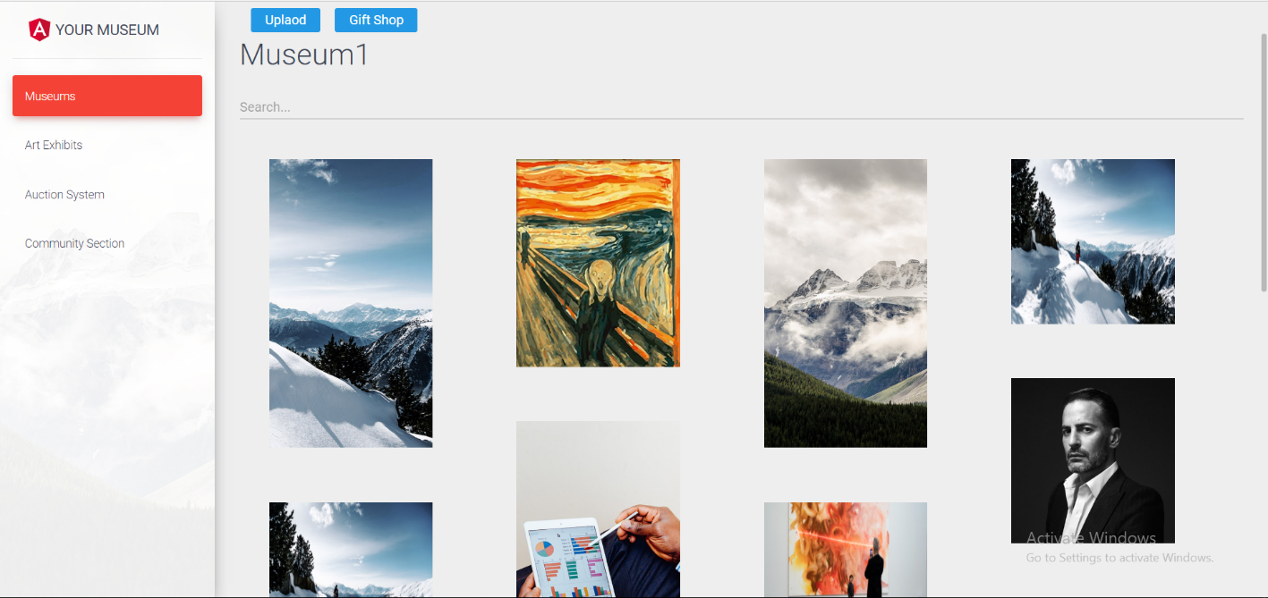

### Art exhibit interface

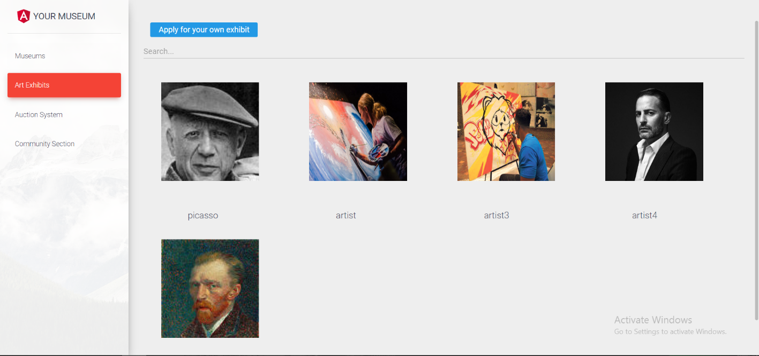

### Auction interface

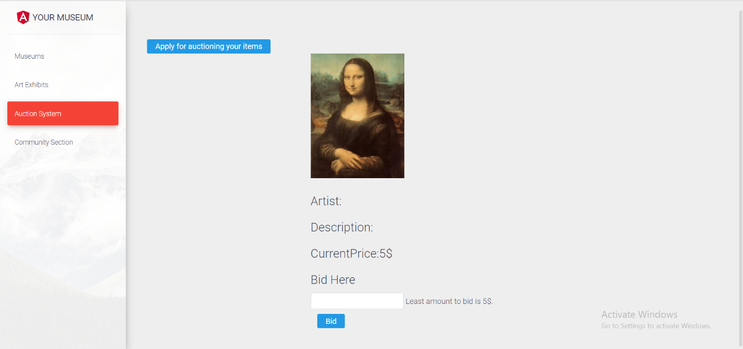

### Community section interface

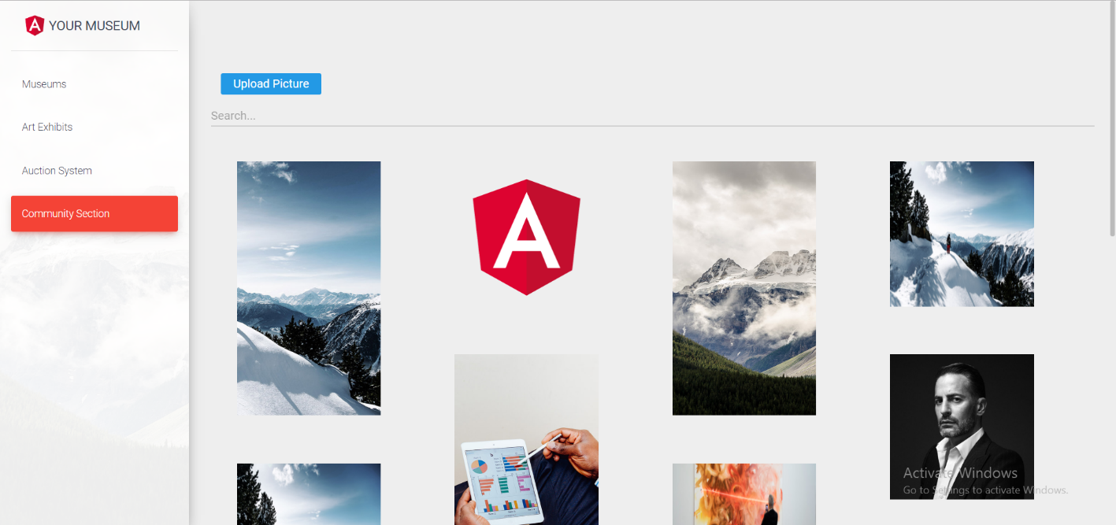

## Hardware Interface

The site operates on normal size pc screen.